**Digital Marketing**

Project Work

* Project Title : Comprehension Digital Marketing For Hyundai motor Company
* Name : Damam Maheshwari
* Team ID : LTVIP2025TMID21819

**Comprehension Digital Marketing For Hyundai Motor Company**

**1. Brand Study , Competitor Analysis & Buyer's/Audience Persona**

**Brand Study**

**Brand Identity**: Hyundai positions itself as an innovative, customer-centric, and future-forward automobile brand. Their tagline, "New Thinking. New Possibilities.", reflects their commitment to quality, technology, and sustainability.

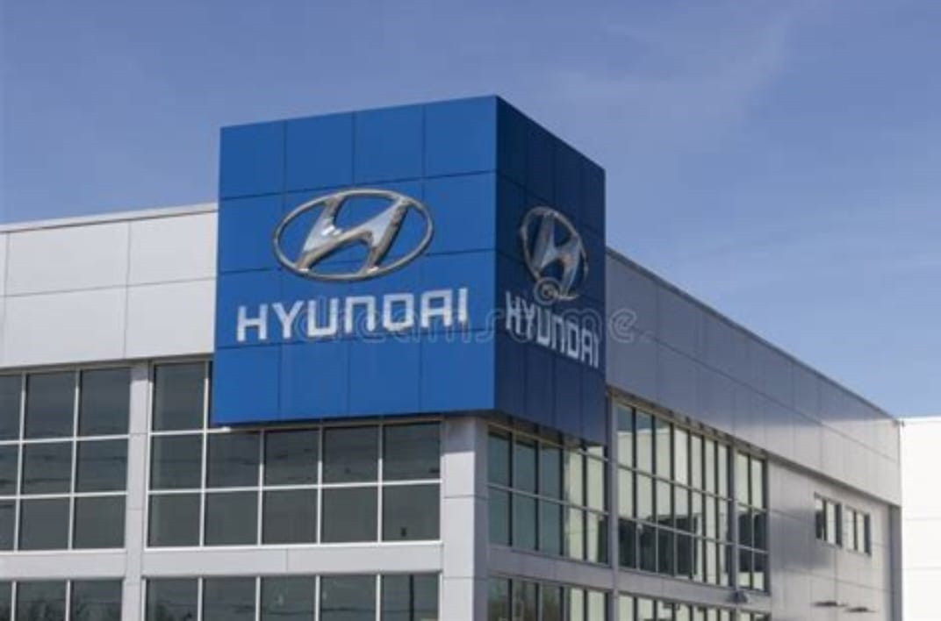

**Brand Perception**: Hyundai is seen as a reliable, stylish, and tech-friendly brand with a mix of budget-friendly and premium vehicles.

* Unique Selling Proposition (USP):
* Advanced technology (SmartSense, Bluelink, fuel cell tech).
* Value-for-money features (Premium features at competitive prices).
* Electric vehicle (EV) focus (Ioniq series, Kona Electric).
* Strong global presence (In over 200 countries).

**Competitor Analysis**

* Key Competitors in the Global Market:
* Toyota (Reliability, hybrid tech, strong resale value).
* Honda (Smooth engine performance, sporty design).
* Volkswagen (Premium build quality, European engineering).
* Kia (Sibling brand, stylish design, affordability).
* Tesla (EV market leadership)

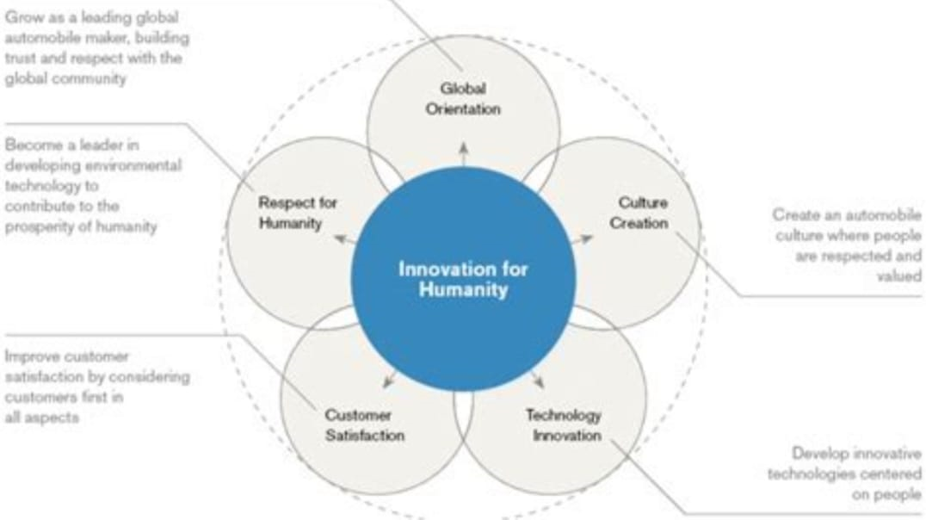.

**Key Competitors in India:**

* Maruti Suzuki (Dominates budget segment, strong service network).
* Tata Motors (Gaining traction with safety-focused SUVs).
* Mahindra & Mahindra (SUV-dominant portfolio, electric push).
* Kia Motors (Competes with Hyundai’s SUVs, aggressive pricing).

**Competitive Edge of Hyundai:**

✔ Feature-packed vehicles at competitive prices.

✔ Strong after-sales service and warranty.

✔ Rapid adoption of electric and hybrid technology.

**Buyer’s / Audience Persona**

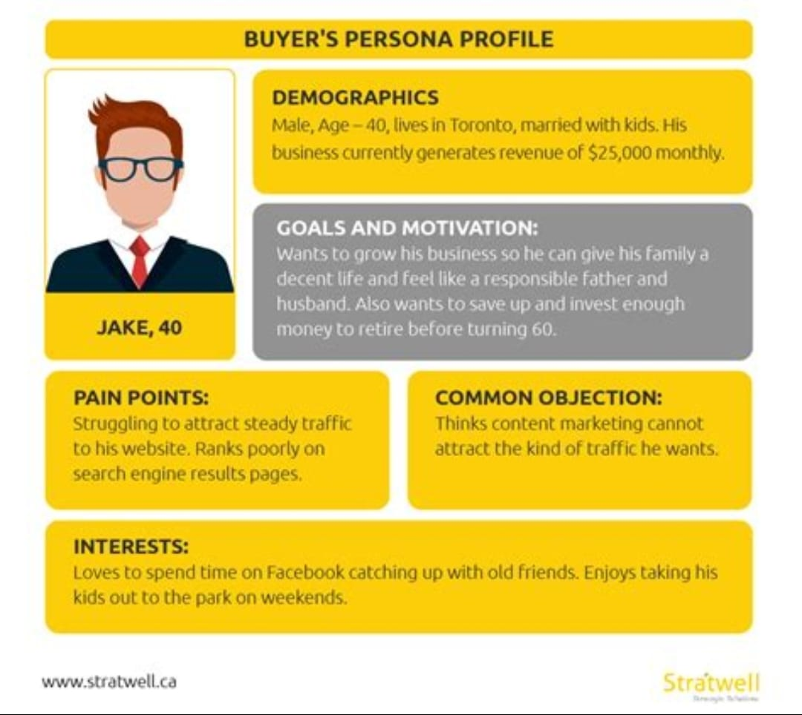

* Urban Professionals (25-40 years)

Want stylish, connected, fuel-efficient cars.

Prefer models like i20, Venue, Creta.

* Family Buyers (30-50 years)

Seek safety, space, and durability.

Prefer Creta, Alcazar, Tucson.

* Young Enthusiasts (18-30 years)

Look for performance, sporty design, tech features.

Prefer i20 N Line, Verna Turbo.

* Eco-Conscious Buyers (25-50 years)

Interested in EVs and hybrids.

Prefer Hyundai Ioniq, Kona Electric.

**2. SEO and Keyword Research**

High-Volume Keywords:

“Hyundai new cars 2025”

“Hyundai Creta vs Kia Seltos”

“Best Hyundai SUVs in India”

“Hyundai EV cars”

“Hyundai car price in India”

**Long-Tail Keywords:**

“Is Hyundai a reliable car brand?”

“Best Hyundai car for family in 2025”

“Hyundai EV range comparison”

“Hyundai vs Maruti: Which is better?”

**SEO Strategy**:

✔ Optimize Hyundai-related blogs and landing pages for high-volume keywords.

✔ Use local SEO for Hyundai dealerships (e.g., “Hyundai showroom near me”).

✔ Focus on YouTube SEO (tutorials, car reviews, test drive videos).

**3. Content Ideas & Marketing Strategies**

* Blog Topics:

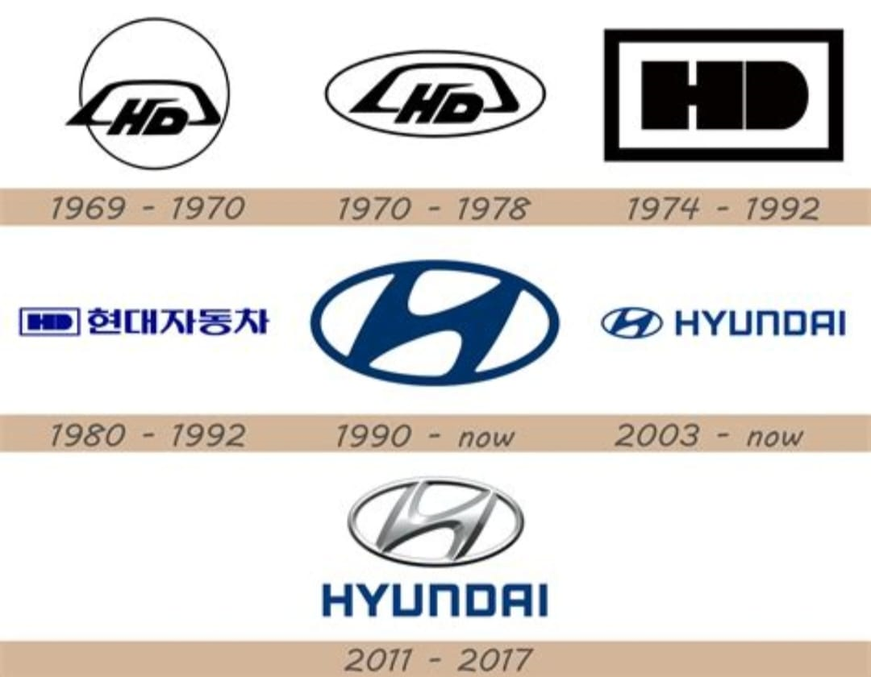

“Top 5 Hyundai SUVs for Indian Roads”

“Hyundai vs Toyota: Which Brand is Better for You?”

“Hyundai EV Lineup: Everything You Need to Know”

* Video Content Ideas:

Hyundai’s safety features explained.

Test drive vlogs of new Hyundai models.

Hyundai vs competitors side-by-side comparison videos

.

* Marketing Strategies:

✔ Influencer marketing (auto vloggers, tech reviewers).

✔ User-generated content (Hyundai owner testimonials).

✔ AR/VR experiences (Virtual test drives).

**4. Design & Video Editing Strategy**

✔ Minimalist & premium aesthetic for Hyundai’s luxury segment (Tucson, Ioniq).

✔ Vibrant and youth-centric visuals for hatchbacks and sedans (i20, Verna).

✔ Story-driven ad campaigns showcasing Hyundai’s reliability and safety.

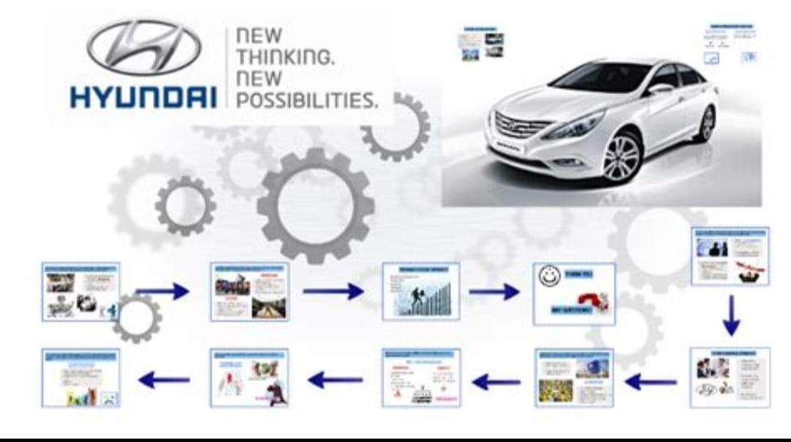

* Video Ad Concepts:

Short Instagram reels featuring “Hyundai in 30 seconds”.

Behind-the-scenes factory tours showing Hyundai’s production process.

Drone-shot commercials showcasing Hyundai’s off-road SUVs.

**5. Social Media Ad Campaign Strategy**

* Platforms to Target:

✔ Facebook & Instagram (Engagement, car features, influencer collabs).

✔ YouTube (Test drives, comparison videos, live Q&A).

✔ Twitter/X (Real-time updates, industry news).

✔ LinkedIn (Corporate branding, sustainability initiatives).

* Ad Campaign Ideas:

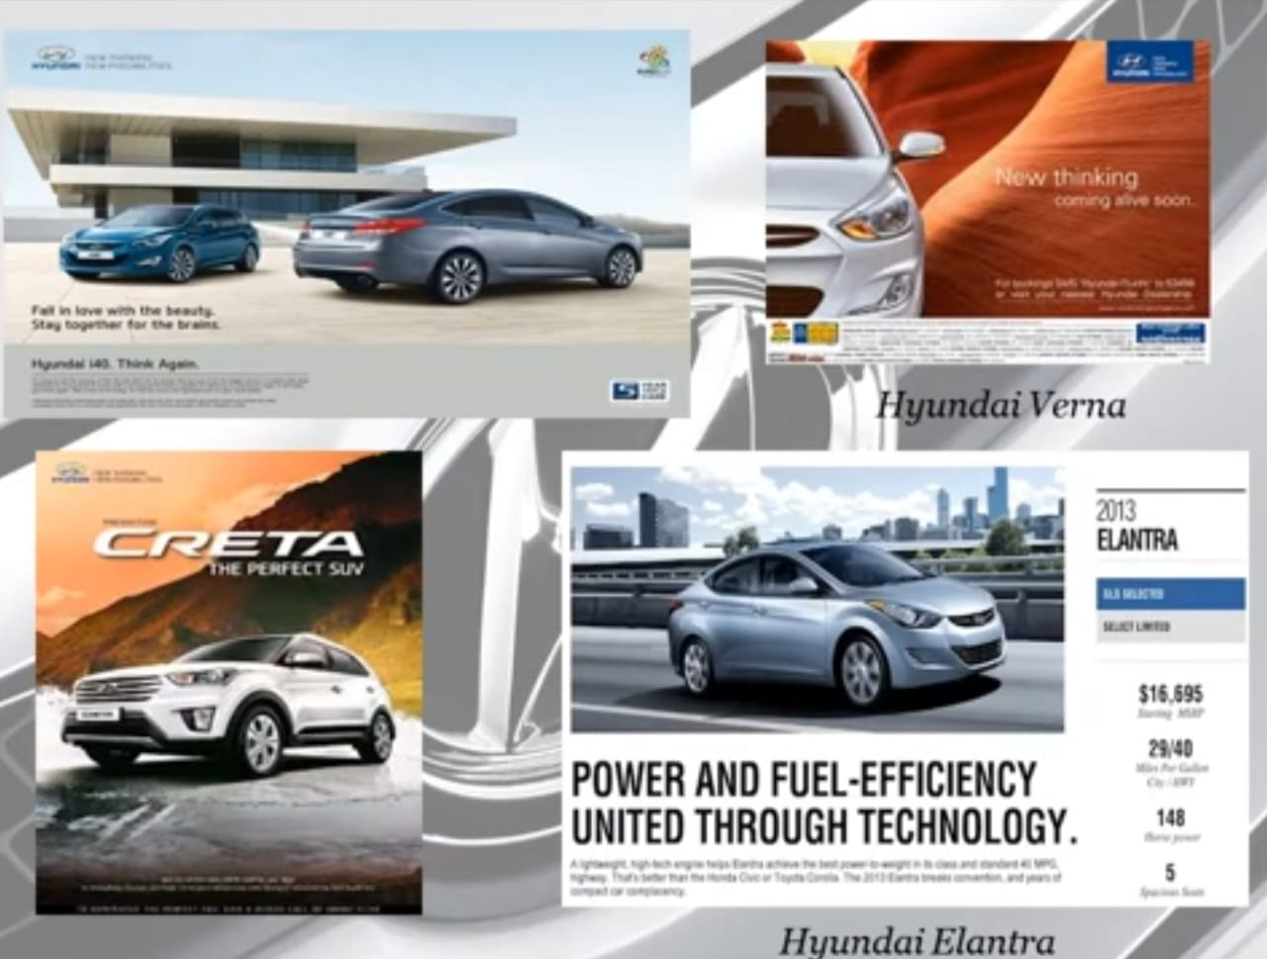

“Drive the Future” – A campaign highlighting Hyundai’s EVs.

“Built for Safety” – Crash test safety features in action.

“Hyundai Adventure” – Showcasing SUVs in tough terrains.

**6. Email Marketing Campaign**

* Email Campaign Ideas:

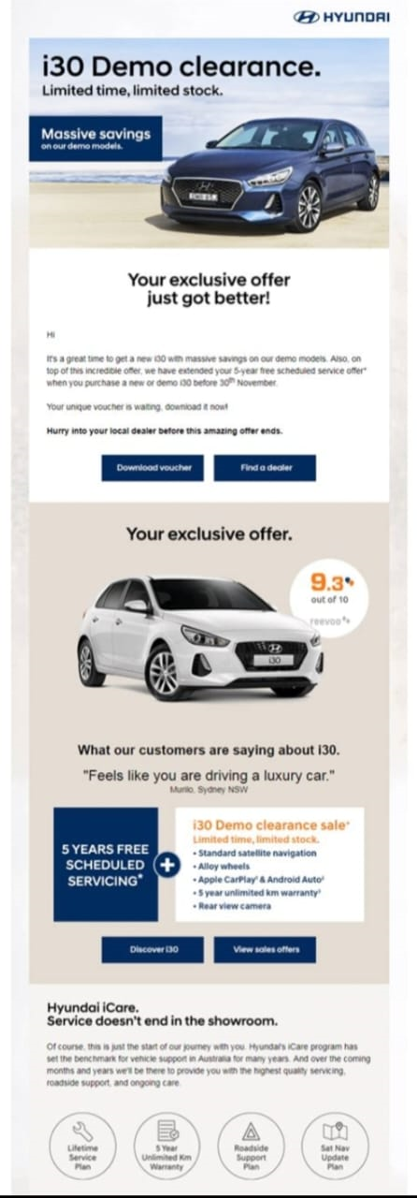

✔ Welcome Series: After a showroom visit, send brochures, testimonials, and financing options.

✔ Personalized Offers: Location-based discount emails.

✔ Festive Discounts: Diwali, Christmas, and New Year deals.

✔ Maintenance & Tips: Regular servicing reminders and car care tips.

* Subject Line Examples:

✔ “Your dream Hyundai is just a test drive away!”

✔ “Exclusive festive offer on Hyundai Creta – Limited Time Only!”

✔ “Hyundai Ioniq: The Future of Driving is Here!”